- Given the root of a binary search tree and a node p in it, return the in-order successor of that node in the BST. If the given node has no in-order successor in the tree, return null. The successor of a node p is the node with the smallest key greater than p.val.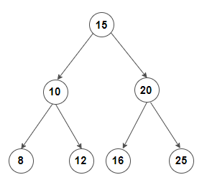
Inorder successor of Node 8 is Node 10.

Solution:

List<TreeNode>in = new ArrayList<>();
public void func(TreeNode root)
{
if(root==null)
return;

func(root.left);
in.add(root);
func(root.right);
}

public TreeNode inorderSuccessor(TreeNode root, TreeNode p) {
if(root==null)return null;
func(root);
for(int i=0;i<in.size();i++)
{
if(in.get(i)==p)
{
if(i==in.size()-1)
return null;

return in.get(i+1);
}
}
return null;
}

- Given the root node of a binary search tree and two integers low and high, return the sum of values of all nodes with a value in the inclusive range [low, high].
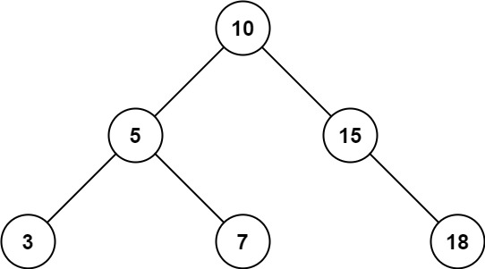

Input: root = [10,5,15,3,7,null,18], low = 7, high = 15
Output: 32
Explanation: Nodes 7, 10, and 15 are in the range [7, 15]. 7 + 10 + 15 = 32.

Solution:

int sum=0;
void helper(TreeNode root, int low, int high)
{
if(root == null)
return;

if(root.val>=low && root.val<=high)
sum+=root.val;

helper(root.left,low,high);
helper(root.right,low,high);

}

int rangeSumBST(TreeNode root, int low, int high) {

helper(root,low,high);
return sum;

}

- Given the root of a binary search tree and a target value, return the value in the BST that is closest to the target.
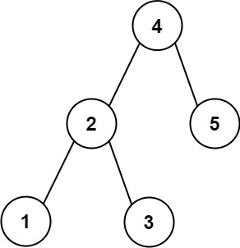

Input: root = [4,2,5,1,3], target = 3.714286
Output: 4

Solution:

int ans=0;
double mini=99999.00;
void use(TreeNode root, double target)
{
if (root == null)
return;

use(root.left,target);

if(Math.abs(target-root.val)<mini)
{
mini=Math.abs(-root.val+target);
ans=root.val;
}

use(root.right,target);

}

public int closestValue(TreeNode root, double target) {
if(root == null)
return 0;

use(root,target);
return ans;

}

- Given the root of a binary tree, determine if it is a valid binary search tree (BST).
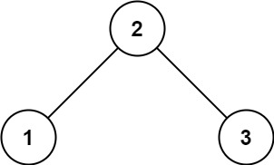

Solution:

bool isBSTHelper(TreeNode root, long min, long max){
if(root == null) return true;
if(root.val <= min || root.val >= max) return false;
boolean left = isBSTHelper(root.left, min, root.val);
boolean right = isBSTHelper(root.right, root.val, max);
return (left && right);
}

bool isBST(TreeNode root) {
if ( root == null )
return true;
return isBSTHelper(root, LONG.MIN_VALUE, LONG.MAX_VALUE);
}

- Given the root of a binary tree, find the largest subtree, which is also a Binary Search Tree (BST), where the largest means subtree has the largest number of nodes.
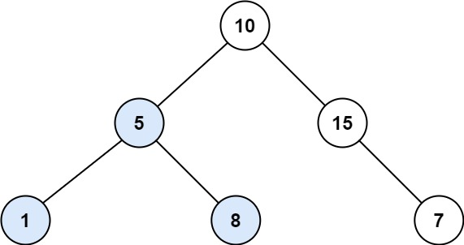

Input: root = [10,5,15,1,8,null,7]
Output: 3
Explanation: The Largest BST Subtree in this case is the highlighted one. The return value is the subtree's size, which is 3.

Solution:

boolean isBST(TreeNode root, Long min, Long max)
{
if(root == null) return true;
if(root.val <=min || root.val >= max) return false;
return isBST(root.left, min, Long.valueOf(root.val))
&& isBST(root.right, Long.valueOf(root.val), max);
}

int count(TreeNode root)
{
if(root == null) return 0;
return 1+count(root.left)+count(root.right);
}

public int largestBSTSubtree(TreeNode root)
{
if(root == null)
return 0;
if (isBST(root, Long.MIN_VALUE, Long.MAX_VALUE))
{
return count(root);
}

int l = largestBSTSubtree(root.left);
int r = largestBSTSubtree(root.right),

return Integer.max(l,r);

}//function closed

- Given the root of a Binary Search Tree (BST), return the minimum difference between the values of any two different nodes in the tree.
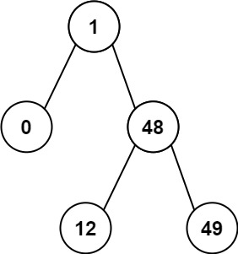

Solution:

ArrayList<Integer>v = new ArrayList<>();

void helper(TreeNode root)
{
if(root == null)return;

helper(root.left);
v.add(root.val);
helper(root.right);

}

public int minDiffInBST(TreeNode root) {
if(root == null)return 0;

helper(root);

int n=v.size();
int mini=Integer.MAX_VALUE;
for(int i=1;i<n;i++)
{
if(v.get(i)-v.get(i-1)<mini)
mini=v.get(i)-v.get(i-1);

}
return mini;

}

